DORING, Jackson (jdori5)

Technology Studies

Design Folio 1

Contents

Design Problem 0

Brief 0

Design Constraints 0

Design Criteria 1

Top 6 design criteria’s 2

Timeline 0

Market Research 0

Item #1 0

Item #2 2

Item #3 4

Prototype #1-Lego 1

Prototype #1 Survey 1

Prototype #2 1

Prototype #2 survey 1

Justification 1

Material List 0

Work Method Statement 0

Construction Process 1

Final Product In Use 4

Appraisal 7

References 0

# Design Problem

2.4 billion people around the world don’t have access to adequate sanitation, that’s one in three of the world’s population *(un.org, 2017).* Poor sanitation predominantly occurs within developing nations. Most communities in these nations don’t have any efficient methods of washing clothes; having dirty clothes can lead to problems such as bad immune systems, diseases and ultimately death. Having these problems present in communities can lead to decreases in education because children are too sick to attend school, which means they don’t get a proper education. Having good education in developing countries can help solve numerous other problems.

# Brief

I will be required to design, manufacture and test a washing machine for developing countries to help solve sanitation. The machine must allow communities from developing countries to effectively and easily wash and sanitize their clothing items with their prior knowledge and resources. The machine is being built to help developing communities better manage their sanitation; which in return lowers disease rates and increases education and health.

# Design Constraints

## Task requirements

Find, design and manufacture a product out of a bicycle that can help fix sanitation in developing countries.

## Material Constraints

The washing machine needs to implement bicycle components and any other necessary materials.

## Time Constraints

The project needs to be completed within a 14-week time frame, due week 6 of term 2.

## Cost Constraints

There is no cost limit for this project, however the product does needs to be as cost effective as possible.

# Design Criteria

## Elements of Design

* Size: the machine needs to fit a minimum of 20 pieces of clothing, so a large washing drum isn’t required.
* The machine needs to incorporate a bicycle

## User Centred Design

* Must be easily operatable by less experienced communities in developing countries
* Must be light enough to transport from community to community

## Materials

* All materials need to be cost effective, sustainable and eco-friendly
* Can’t be too heavy, needs to be easily transportable

## Legal Responsibilities

* Must be an original idea so no copy infringements arise
* Can’t have any elements that can easily cause injury to users
* Can’t be heavy; to prevent cause muscle or ligament injuries for users while carrying or transporting

## Manufacturing Process

* The machine needs to be manufactured using equipment provided by the school

## Sustainable Design

* There should be minimal maintenance during the life of the product
* Built to last
* Must be a sturdy construction.

## Ergonomics

* The machine must be comfortable and desirable to use by majority of users
* All user interactions with the machine needs to be comfortable and natural to hold and operate.

## Anthropometrics

* All interactive components of the machine need to be correctly proportioned with average body sizes of adults for a better user-centred design

## Aesthetics

* The washing machine doesn’t need to look good because the design needs to be more functionality focused
* The limited resources and time required to develop the product also restricts time able to spend on aesthetics.

The final machine needs be comfortable and anthropometrically sound for majority of users in developing countries to operate. It needs to mainly be built using bicycle parts, power tools, hand tools and welding equipment. The machine also needs to survive harsh conditions, have along life duration, can’t be too heavy and must be safe to use. It also needs to be an original idea to avoid any legal breaches.

# Top 6 design criteria’s

***User centred design;***must be easily operatable by less experienced communities in developing countries.

***Materials;*** all materials need to be cost effective, sustainable and eco-friendly

***Sustainable design;*** there should be minimal maintenance during the life of the product

***Anthropometrics;*** all interactive components of the machine need to be correctly proportioned with average body sizes of adults for a better user-centred design

***Sustainable design;*** built to last

***User centred design;*** must be light enough to transport from community to community

From the design criteria list I created, I have selected 6 which I feel are the most important for the success of this task. I believe these are important because they concentrate on the needs of developing counties more than the others, which will help solve the issue of sanitation because the solutions are tailored for their needs.

I have then placed these 6 criteria’s into a criteria sheet; grading each criteria from A-standard to C-standard, depending on the successfulness of its integration. This will help me critically analyse the success of my machine during and at the end of the development.

Top 6 design criteria sheet

|  |  |  |  |
| --- | --- | --- | --- |
|  | A standard | B standard | C standard |
| User centred design | * Comprehensive analysis and effective implementation of design features to better suit the machine for developing communities * Thorough design plans and effective use of materials to create an easily transportable machine | * Analysis and effective implementation of design features to better suit the machine for developing communities * Detailed design plans and use of materials to create an easily transportable machine | * Effective implementation of design features to better suit the machine for developing communities * Descriptive design plans and use of materials to create an easily transportable machine |
| Materials | * Comprehensive and discerning analysis of material choices for a cost effective, eco-friendly and sustainable machine | * Detailed analysis of material choices for a cost effective, eco-friendly and sustainable machine | * Analysis of material choices for a cost effective, eco-friendly and sustainable machine |
| Sustainable design | * Discerning research and use of materials to minimise maintenance during the life of the machine * Sufficient and effective use of suitable materials and design plans to help the machine withstand harsh conditions and last for years | * Proficient research and use of materials to minimise maintenance during the life of the machine * Effective use of suitable materials and design plans to help the machine withstand harsh conditions and last for years | * Research and use of materials to minimise maintenance during the life of the machine * Use of suitable materials and design plans to help the machine withstand harsh conditions and last for years |
| Anthropometrics | * Thorough analysis and implementation of anthropometrics for a better user centred design | * Detailed analysis and implementation of anthropometrics for a better user centred design | * Analysis and implementation of anthropometrics for a better user centred design |

# Timeline.

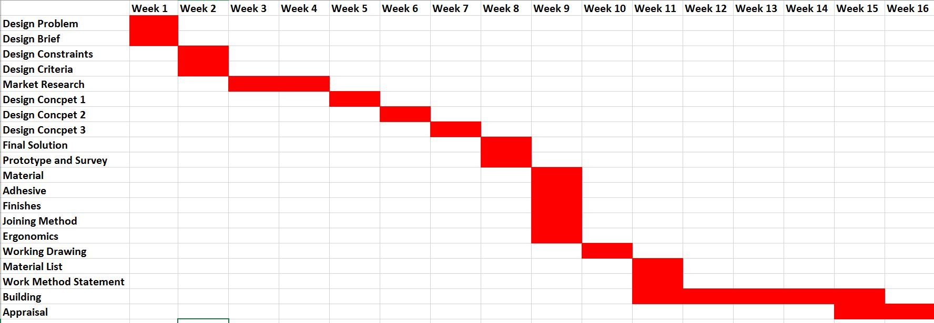

# Market Research

# Item #1

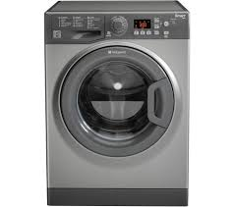

|  |  |  |
| --- | --- | --- |
| Positive | Minus | Interesting |
| Can efficiently clean clothes | Can’t be made from bicycle parts | Many different settings to help with sanitation |
| Doesn’t leak water | Can’t be used in developing countries due to lack of power | Automatically operatable |
| 40L washing machine can fit lots of clothes | Uses too much water | Aesthetically pleasing |
| Easily useable by majority of people | Can’t be repaired using bicycle parts |  |

## Opinion of product

The product works excellent at washing and sanitizing clothing items. However, the washing machine can’t be made using primarily bicycle parts. Therefore, wouldn’t be suitable for this task.

## Design Criteria

### User centred design

The machine includes a variety of different settings to help users with selecting the correct method for washing certain clothing items. The machine also doesn’t need a user manually operating the machine while in use, this helps to minimise the effort required to wash clothes. It’s too heavy to easily transport from one community to another.

### Aesthetics

The clean, simplistic, modern look of the washing machine gives a pleasing visualization for the owner and operators of the machine.

### Ergonomics

Having the dial control a circle creates a more comfortable operation because hands can easily wrap around it comfortably.

### Anthropometrics

Having the controls at the average hand height for adults while standing creates a better user centred design.

### Legal Responsibilities

Having the edges of the washing machine curved creates a safe environment for all users of the machine especially children. There are also hundreds of similar products to this which makes it prone to legal difficulties.

### Manufacturing Process

This product wouldn’t be suitable to mass produce in developing countries due to the extensive, expensive and complicated tools and materials used to manufacture this washing machine.

### Materials

The product is made using mainly stainless steel and aluminium, which can be expensive.

### Sustainable Design

The product is made using strong materials which means it is made to last and can withstand harsh conditions. There is also minimal maintenance because it’s well designed and manufactured.

This product wouldn’t be suitable as a solution. This is because the machine requires constant electricity to run ad consumes large amounts of water per wash. Both electricity and clean water a scarce in developing countries, not making it a practical choice. Once implemented in communities, it will be difficult for local people to repair the machine because there are lots of complicated mechanics that typically experts can only fix also, if someone knew how to repair it, they wouldn’t be able to because the resources aren’t available to them.

## Reference

<https://www.google.com.au/search?q=washing+machine&safe=strict&source=lnms&tbm=isch&sa=X&ved=0ahUKEwi58NbYicHSAhVBk5QKHWYzDiwQ_AUICSgC&biw=1163&bih=559#imgrc=UlGrtaXKTygSBM>

# Item #2

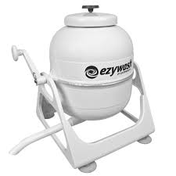

|  |  |  |
| --- | --- | --- |
| Positive | Minus | Interesting |
| Portable | Water source needed | Interesting design |
| Can effectively wash clothes | Can only hold limited clothing items | Made from strong, durable materials |
| Easily operatable | Not made using primarily bicycle parts |  |
| Small and compactable | Can’t be fixed using bicycle parts |  |

## Opinion of product

The washing machine works well to effectively and efficiently wash clothes. There are a few improvements that could make this product better. These improvements include replacing the automatic water distribution with manually pouring water instead. This will allow the machine to be used in a greater variety of environments, which may not have water sources. Another improvement that could be made, is creating a bigger washing cylinder to allow for more clothing items to be washed at once. However, the product does effectively wash and sanitize clothes.

## Design Criteria

### User centred design

Having a handle powered washing machine allows the user to easily operate the product, without any complicated mechanics. It is also convenient for use in remote locations.

### Ergonomics

Having a handle powered washing machine creates a comfortable and more desirable use of the product. It’s also easier for users to wrap their hands around a cylinder handle.

### Anthropometrics

Having the handle at the average hand height of an adult while sitting makes the operation more comfortable.

### Aesthetics

Having a simplistic, bland design creates a visually appealing product for the user because there is not clutter and useless features.

### Materials

The main material used to construct this product is metal, this is an excellent choice for the machine because metal is a common material found on bicycles and is also cheap to purchase and use.

### Manufacturing Process

The manufacturing process for this machine would be simple because there’s no complex mechanics required.

### Sustainable Design

Using strong and durable materials like metal helps it withstand harsh conditions, this combined with the simplistic design and mechanics of the machine means it would be easily repairable in developing countries, increasing the products life expectancy.

### Legal Responsibilities

The original idea of the machine means there would be no troubles with copyright infringements. There are also no elements of the machine that can easily cause injury to users. The light weight design also helps reduce muscle injury while moving.

This product wouldn’t be suitable as a solution. This is because the machine requires a water connection to operate, this isn’t practical for developing countries because they lack reliable water connections. The machine also doesn’t incorporate bicycles, which doesn’t meet the requirements of the task.

## Reference

[https://www.google.com.au/search?q=washing+machine&safe=strict&source=lnms&tbm=isch&sa=X&ved=0ahUKEwi58NbYicHSAhVBk5QKHWYzDiwQ_AUICSgC&biw=1163&bih=559#safe=strict&tbm=isch&q=camping+washing+machine&*&imgrc=W35hOnTO_eWybM](https://www.google.com.au/search?q=washing+machine&safe=strict&source=lnms&tbm=isch&sa=X&ved=0ahUKEwi58NbYicHSAhVBk5QKHWYzDiwQ_AUICSgC&biw=1163&bih=559#safe=strict&tbm=isch&q=camping+washing+machine&*&imgrc=W35hOnTO_eWybM)

# Item #3

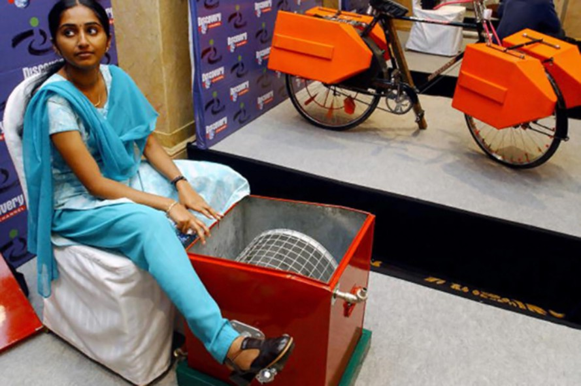

|  |  |  |
| --- | --- | --- |
| Positive | Minus | Interesting |
| Cheap to manufacture | No effective way to remove water | Not a complicated design |
| Easily operatable | Can only hold limited clothing | Small and compact |
| No power or water source needed | Hard to remove clothes |  |
| Can be made and fixed using bicycle parts |  |  |

## Opinion of product

The product works well to some extent, there are some improvements that could make it more relevant to the needs of developing countries. These improvements include; making the cylinder inside to have no holes, implementing a larger cylinder could accommodate more clothing, these modifications could improve the efficiency of the machine.

## Design Criteria

### User centred Design

The machine can be easily operated by majority of people in developing countries. Powering the machine by pedal allows the user to happily operate the machine because it’s just like riding a bicycle.

### Ergonomics

Users of the machine can sit while operating the machine, this creates a more comfortable and desirable operation.

### Anthropometrics

Having the pedals at the average adult’s leg length away while sitting, allows the user to comfortably place their legs straight across onto the pedals.

### Aesthetics

The machine doesn’t look aesthetically pleasing due to the ridged and worn out sides. However, the red colour does make the machine look more appealing.

### Legal Responsibilities

The machine is an original idea and wouldn’t have any troubles with copy right infringements. The light weight design helps decrease muscle damage while moving. However, there are a few sharp surfaces that can cause injury to users.

### Manufacturing Process

The simplicity of the product would make manufacturing easy. Only a few power tools would be required to construct it due to the minimal moving and connected parts.

### Materials

The machine is made using primarily metals, this would be good for developing countries because it’s an easily accessible and cheap material.

### Sustainable Design

The use of strong durable materials will give the product a long-life expectancy due to its resistance to harsh conditions. Having simple mechanics allows people in developing countries to repair it.

This product isn’t suitable as a solution. This is because once water has been placed in the machine, there is no effective way of removing the water without wasting it. This isn’t practical in developing countries because water is scarce and they can’t afford to lose any. It’s also hard to remove clothing items because the cylinder isn’t removable and there isn’t a hatch on the cylinder for removing clothes. The product also doesn’t incorporate any bicycles, which means it doesn’t meet the design requirements for the task.

## Reference

[https://www.google.com.au/search?q=camping+washing+machine&safe=strict&source=lnms&tbm=isch&sa=X&ved=0ahUKEwiTvKKRi7nSAhXDFZQKHcynA9EQ_AUICSgC#safe=strict&tbm=isch&q=bicycle+powered+washing+machine&*&imgrc=Mqxxd3hd2EjizM](https://www.google.com.au/search?q=camping+washing+machine&safe=strict&source=lnms&tbm=isch&sa=X&ved=0ahUKEwiTvKKRi7nSAhXDFZQKHcynA9EQ_AUICSgC#safe=strict&tbm=isch&q=bicycle+powered+washing+machine&*&imgrc=Mqxxd3hd2EjizM)

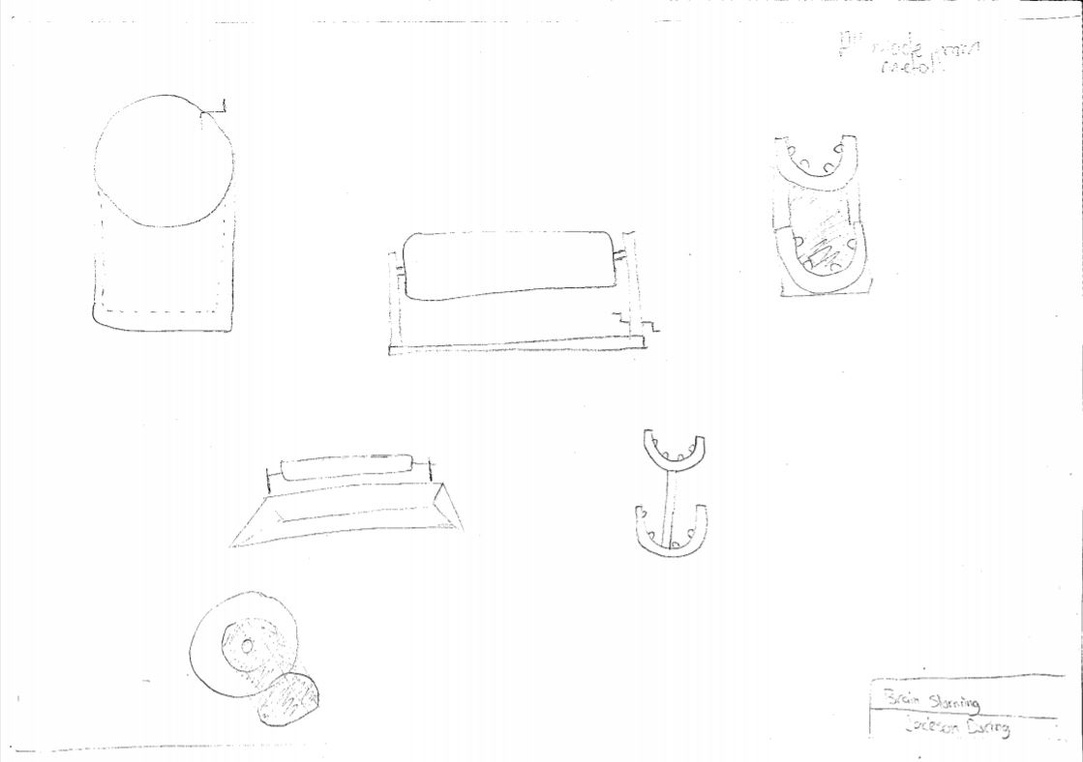

Brainstorm

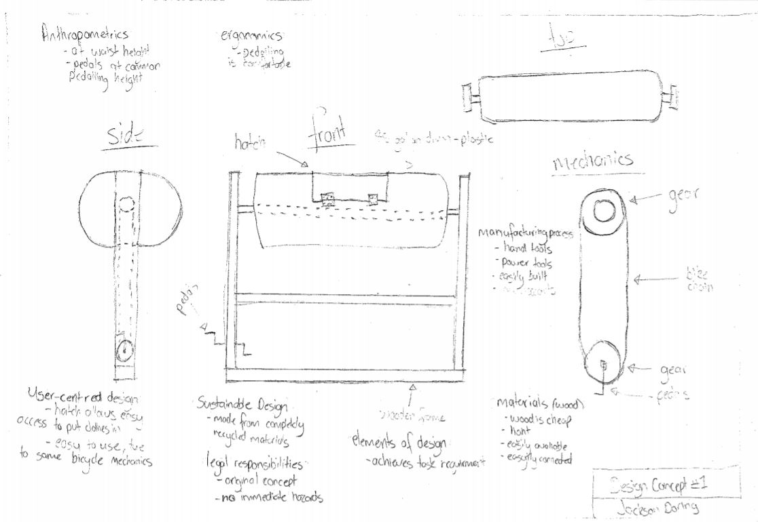

*Anthropometrics:*

* Barrel at waist height
* Pedals at ideal height

*User centred design:*

* Hatch allows easy access to clothes
* Easy to use, due to same mechanics as bicycles

Sustainable Design

* Made completely from recycled materials

Manufacturing process;

Built using accessible tools

Materials (wood)

* Cheap
* Light
* Easily available
* Easy to work with

Elements of design

* Achieves task required

Legal Responsibilities

* Original concept
* No immediate hazards

*Ergonomics:*

* Comfortable to pedal

Design Concept 1

|  |  |  |
| --- | --- | --- |
| Positive | Minus | Interesting |
| Good anthropometrics and ergonomics | Difficult to move | Operated by bicycle pedals |
| Easy access to put clothes in | Can’t survive in rough environments | Any age can operate |
| Made from cheap, recycled materials | Complicated to manufacture |  |

## Design Criteria

### Sustainable Design

The use of recycled materials lowers the eco-footprint when manufacturing this machine. However, the choice of wood for the frame doesn’t create a “built to last” product due to the low durability of wood in rough environments.

### Ergonomics

The use of bicycle pedals for the main operation of the machine creates a comfortable and more desirable approach for users because of its simplistic use.

### Anthropometrics

Having the hatch for putting clothes in at the average waist height for adults and the pedals slightly raised above the ground, like bicycles, creates a more user-centred design.

### User-centred Design

The hatch allows for easier access to put clothes into the washing machine. Having the mechanics of the machine like the ones on bicycles allows any age to easily operate it.

### Materials

The wooden frame doesn’t create a durable, long lasting life expectancy because wood isn’t particularly strong and can’t withstand harsh environments.

### Manufacturing Process

The manufacturing process for the product will be quite complicated due to having to join multiple materials; such as wood to metal, and plastics to metal.

### Legal Responsibilities

There shouldn’t be any legal difficulties with this design due to the original concept and no immediate hazards present for users while operating.

### Aesthetics

The design isn’t very aesthetically pleasing due to the restrictions on materials and the task doesn’t require the machine to look nice.

This design would be a suitable solution because it’s able to effectively and easily wash and sanitize clothes using the prior knowledge and resources from developing countries, which helps meet the design requirements of the task. It also has good anthropometrics and ergonomics, making the machine comfortable and easy to use by majority of people. It would also be good solution because it’s made from cheap and recyclable Martials, making the machine sustainable which is important for developing countries.

However, the machine would be hard to move because it’s heavy, not making it practical for transporting from community to community. The machine would also be bad for developing countries because it can’t withstand harsh conditions because of its wood design, not making it suitable for developing countries because they require a machine that can withstand these harsh conditions.

## Comments

|  |  |  |
| --- | --- | --- |
| Date | Person: | Comment: |
| 31/03 | Harry Conroy (peer) | * The wood material won’t be able to survive rough environments in developing countries. * Difficult to manufacture in the time frame. |
| 31/03 | Mr Wodson (teacher) | * Difficulties standing up right on hills and slants. |
| 31/03 | Adam Curtis (peer) | * Wood isn’t a durable material, metal would be a better option. |

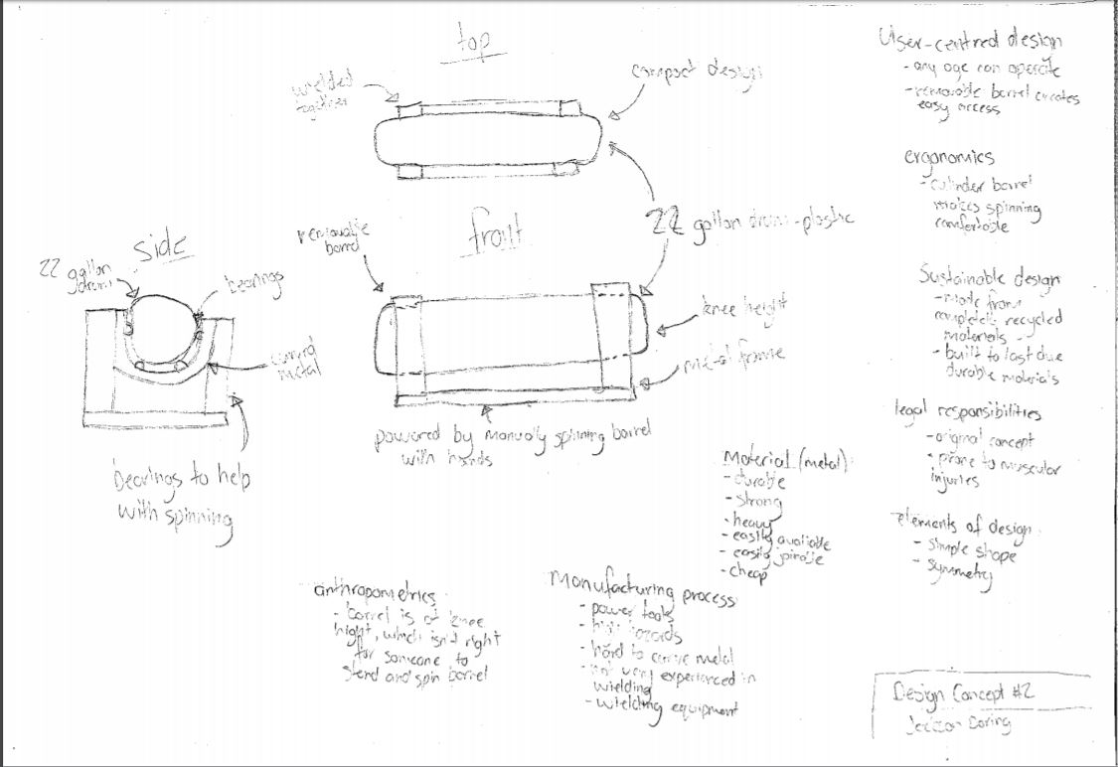

User-centred design

* Any age can operate
* Removable barrel creates easy access

Ergonomics

* Cylinder barrel makes spinning comfortable

Sustainable design

* Made from completely recyclable materials
* Built to last

Legal responsibilities

* Original concept
* Prone to muscular injuries when lifting barrel

Elements of design

* Simple shape
* Symmetrical

Anthropometrics

* Barrel is at knee height, which is bad for someone who’s trying to spin the barrel

Manufacturing process

* Built using accessible tools

Material (steel)

* Durable
* Strong
* Heavy
* Easily available
* Easy to work with
* cheap

Design Concept 2

|  |  |  |
| --- | --- | --- |
| Positive | Minus | Interesting |
| Can withstand harsh conditions | Poor anthropometrics | Removable barrel |
| Easily manufactured | High hazard levels | Any age can operate |
| Easy to operate | A lot of manual work to operate |  |

## Design Criteria

### Sustainable Design

The use of completely recycled materials means it is very eco-friendly and is an effective use of reusable materials. The design is also “built to last” because the use of durable and strong materials like metal will be used.

### Ergonomics

Using a cylinder for the washing barrel creates a more comfortable operation while spinning it with hands because hands can comfortably mould around the cylinder.

### Anthropometrics

The frame is too small, only reaches knees of the users. Having the frame up to the waist of users would create a more comfortable operation.

### User-centred Design

The simple mechanics of the machine allows anyone of any age to easily operate it. The removable barrel also creates easy access to put and take out clothes from the barrel.

### Materials

The use of metal for the machine is an appropriate choice because it is easily available, durable, strong, and cheap and can be easily joined together. However, metal is a heavy material, which means if too much is used it will be hard to move around.

### Manufacturing Process

Power tools and welding equipment will be needed to build this product. With the use of welding equipment comes high hazards, which the appropriate equipment will be worn. Lack of experience with metal work will be a challenge while manufacturing this.

### Legal Responsibilities

The design shouldn’t have any copy right problems because of the original concept. However, the design is prone to giving users muscular and back problems due to the constant need to bend over while operating it.

### Aesthetics

The design isn’t very aesthetically pleasing due to the restrictions on materials and the task doesn’t require the machine to look nice.

This design would be a suitable solution because it’s able to withstand harsh conditions because of its metal design. Using metal also means the design is very sustainable because the steel is able to be recycled and put to other use. Steel is also a material that can be used for many years, not requiring new machines to be built frequently. The mechanics of the machine is very simple, which means it’s able to be manufactured easily, and also able to be repaired by people in developing countries, this helps to meet the design requirements of the task.

However, the machine is prone to muscular/back injuries because users have to bend their backs to lift the barrel out of the holder which also means the machine becomes vulnerable to legal difficulties. The machine also has lots of manual labour required to operate because the user has to sit on the ground and use their hands to spin the barrel, this can become tedious and frustrating for some people, not making it a practical fit in developing countries.

## Comments:

|  |  |  |
| --- | --- | --- |
| Date | Person: | Comment: |
| 07/04 | Harry Conroy (peer) | * Not very aesthetically pleasing. |
| 07/04 | Ryan Chessells (peer) | * Not stable, could fall over. * The barrel will fall out the side. |
| 07/04 | Brendan Pritchard (peer) | * Not weather resistant; prone to rust from rain. |

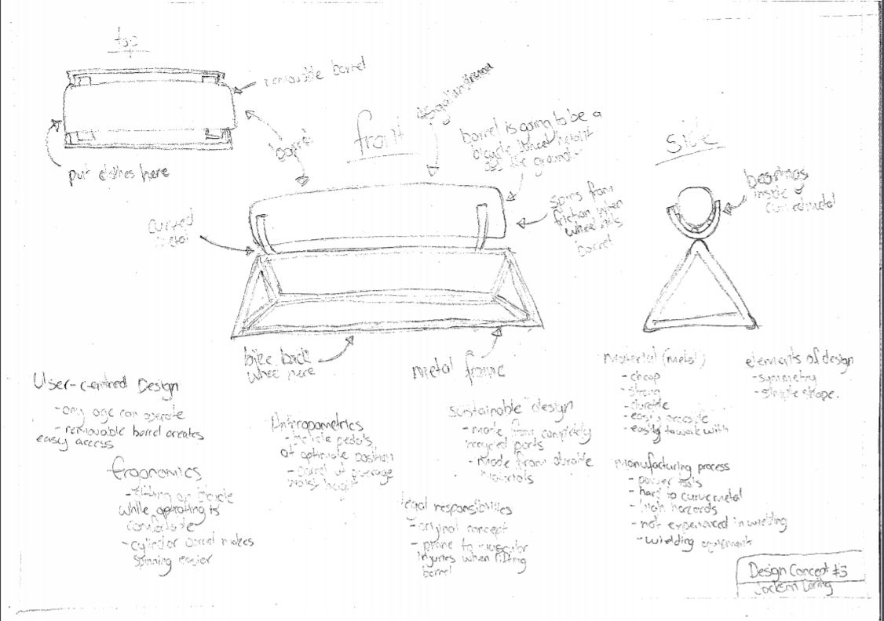

User-centred design

* Any age can operate
* Removable barrel creates easy access

Ergonomics

* Sitting on bicycle is comfortable
* Cylinder barrel makes spinning easier

Anthropometrics

* Bicycle pedals at optimal height
* Barrel at average waist height for adults

Sustainable design

* Made from completely recyclable materials
* Made from durable metal

Legal responsibilities

* Original concept
* Prone to muscular injuries when lifting barrel

Manufacturing process

* Built using accessible tools

Elements of design

* Symmetrical
* Simple shape

Material (steel)

* Cheap
* Strong
* Durable
* Easily accessible
* Easy to work with

Design Concept 3

|  |  |  |
| --- | --- | --- |
| Positive | Minus | Interesting |
| Simplistic | Big; hard to move around | Powered by bicycle |
| Easy to use | Barrel will fall out the side | Any age can operate |
| Comfortable operation |  |  |

## Design Criteria

### Sustainable Design

The use of completely recycled materials makes this design very eco-friendly. Durable materials will also be used for the design which means the machine can survive harsh conditions and is “built to last”.

### Ergonomics

Being able to sit down and use the machine at the same time creates a more comfortable operation.

### Anthropometrics

Having bicycle pedals at the ground is the optimal spot for people to sit on the bicycle and pedal because the distance from the seat to the ground is the height of their legs. Also, having the barrel at average adult waist height is good for ease of use.

### User-centred Design

The simplicity of the machine means any age can operate it, which fits well with the design requirements. Having a removable barrel on the machine makes it easy for people to put and take clothes out.

### Materials

Using metal to build the machine means it can be accessible from a lot of places. Steel is also a durable, cheap and resilient material which is good for developing countries because it can last long and be more effective than other materials. It is also easy to work with.

### Manufacturing Process

The tools that will be required to manufacture this machine is power tools, and welding equipment. There are lots of hazards when working with metals and welding because of the potential burns and cuts. However, these hazards will be controlled with proper control. It will also be difficult to manufacture this design due to my limited knowledge in metal works.

### Legal Responsibilities

There shouldn’t be any problems with copy right infringements due to the original concept. However, the design is prone to muscular and back injuries due to the requirement to lift a barrel of clothes off the stand which can be heavy.

### Aesthetics

The design isn’t very aesthetically pleasing due to the restrictions on materials and the task doesn’t require the machine to look nice.

This design would be a suitable solution because it has a very simplistic design, which makes it easy to manufacture, and is also able to be easily fixed by people in developing countries. Having the machine operatable by something as simple as riding a bike can make washing clothes fun, hassle free, and more desirable by any age, making it a practical choice for developing countries because. The machine is also able to effectively wash and sanitize clothes, meeting the design requirements of the task.

However, the machine would be hard to move from community to community because of its bulky, heavy design, which wouldn’t make it practical for a developing country. The barrel is prone to falling out the side if the machine is on a slant or is being spun too quickly, making it frustrating for users to wash clothes.

## Comments:

|  |  |  |
| --- | --- | --- |
| Date | Person: | Comment: |
| 14/04 | Liam Preston (peer) | * Prone to falling over on slopes because of force from bicycle. * The barrel can fall out the side. |
| 14/04 | Cameron Affleck (peer) | * Doesn’t look good. |
| 14/04 | Mr Wodson (teacher) | * Be hard to lift the barrel out when full of clothes. * Not water resistant; prone to rust. |

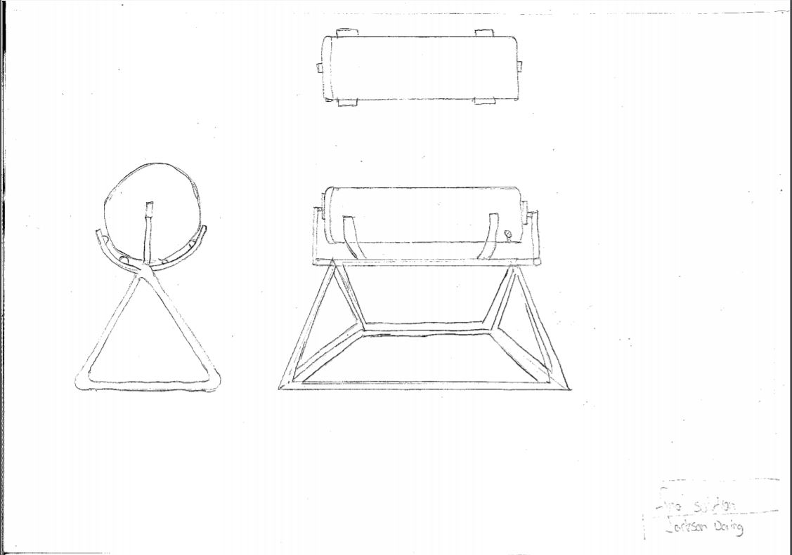

Final Solution

## Justification

I have chosen concept 3 for my final solution. I have selected this one because it can effectively help to solve the problem of sanitation in developing countries. I have done this by creating an effective and efficient way for communities to wash and sanitize clothing. Being able to operate the machine by doing something as simple as riding a bicycle can have major impacts on developing countries because it reduces the amount of hard labour associated with day-to-day operations, it also allows individuals to concentrate on more important tasks such as school because of the time saved by doing these over traditional methods. This design is also able to be put to other uses, by using the bicycle for transportation, and the barrel for collecting water. This is good for developing countries because they’re able to get multiple uses out of one machine, saving them money and resources which is critical in these communities. Also, having the machine easily repairable by non-experts in developing countries means it can be constantly operation for a longer, making the design more sustainable because less machine are being built more often. This design is also able to effectively meet the top 6 design criteria better than the others, making it a better solution for this project.

# Prototype #1-Lego

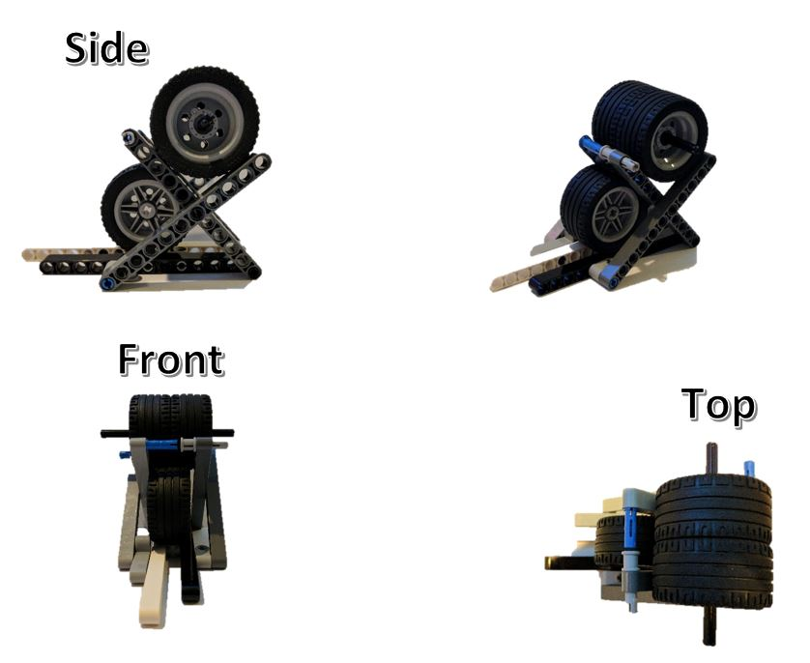

# Prototype #1 Survey

## Outline:

Using the prototype I created in class using Lego I have surveyed knowledgeable and non-knowledgeable people in Technology Studies. The survey includes a rating of the Aesthetics, Ergonomics, Anthropometrics, Manufacturing Process, Elements of Design, User Centred Design, Legal Responsibility, Materials and Sustainable Design.

I have surveyed expert people to get their professional opinion about the mechanics, functionality and approach of the design. I have also surveyed non-expert people to get a more user centred opinion on how average people perceive the design and the real-world practicality of the machine.

From this information, modifications will be made to the product to ensure all aspects are considered and all design features are strongly present in the design.

**Experts include:** Teachers and fellow peers in same class.

**Non-experts include:** Anyone else.

**Key:** 1-10; 1 being the lowest and 10 being the highest.

## **Experts**

|  |  |  |  |  |
| --- | --- | --- | --- | --- |
| Design Criteria | Person 1 | Person 2 | Person 3 | Total (out of 30) |
| Aesthetics | 3 | 7 | 7 | **17** |
| Ergonomics | 8 | 10 | 7 | **25** |
| Anthropometrics | 9 | 9 | 8 | **26** |
| Manufacturing Process | 7 | 10 | 8 | **25** |
| Elements of Design | 10 | 8 | 9 | **27** |
| User-centred Design | 10 | 5 | 7 | **22** |
| Legal Responsibilities | 10 | 9 | 9 | **28** |
| Sustainable Design | 7 | 9 | 6 | **22** |
| Materials | 8 | 9 | 8 | **25** |
|  |  |  |  | 217 / 270 |

## Non-experts

|  |  |  |  |  |
| --- | --- | --- | --- | --- |
| Design Criteria | Person 1 | Person 2 | Person 3 | Total (out of 30) |
| **Aesthetics** | 5 | 4 | 5 | **14** |
| **Ergonomics** | 4 | 7 | 6 | **17** |
| **Anthropometrics** | 8 | 6 | 7 | **21** |
| **Manufacturing Process** | 10 | 7 | 5 | **22** |
| **Elements of Design** | 8 | 8 | 6 | **22** |
| **User-centred Design** | 8 | 8 | 8 | **24** |
| **Legal Responsibilities** | 9 | 8 | 8 | **25** |
| **Sustainable Design** | 9 | 8 | 8 | **25** |
| **Materials** | 9 | 10 | 9 | **28** |
|  |  |  |  | 198 / 240 |

## Comments

|  |  |  |
| --- | --- | --- |
| Date | Person: | Comment: |
| 19/04 | Mr Rogers (teacher) | * Implementing a mechanism that allows communities to drain water contents from the barrel can be greatly beneficial because it allows them to filter it and turn it into drinking water. |
| 19/04 | Cameron Affleck (peer) | * Doesn’t look good. * Good for developing communities |
| 19/04 | Tyler Gilmore (peer) | * Very user-centred design * Good for developing communities |

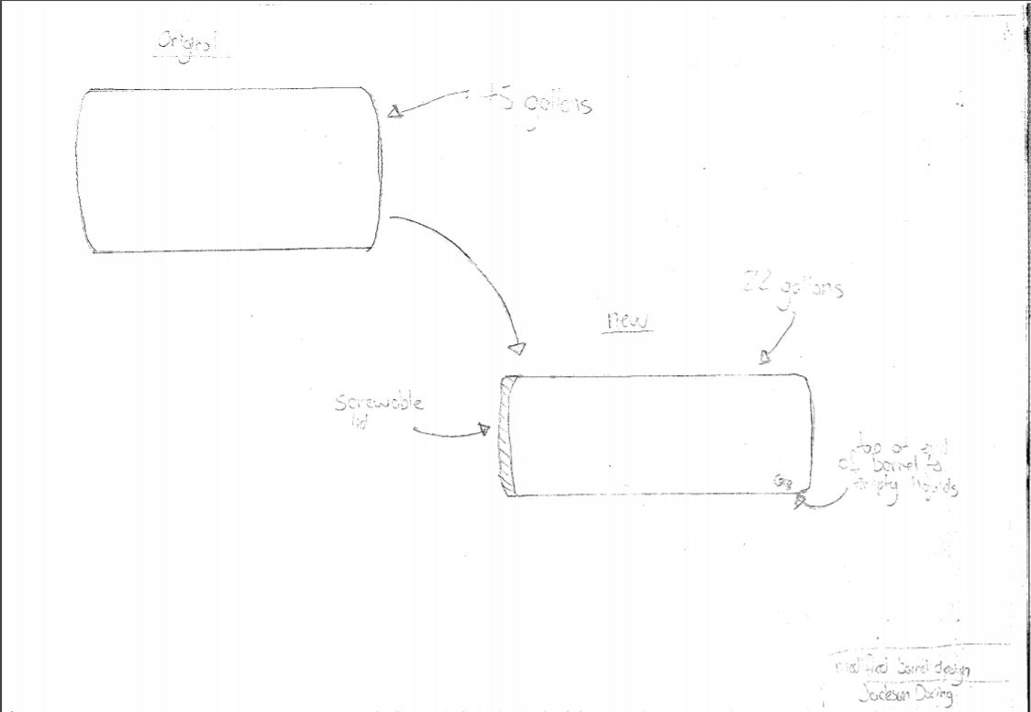

Prototype Modification #1

### Justification

After the feedback I received from the prototype survey I have decided to modify the design of the barrel to be more user friendly, easy to use and have a multipurpose build. The modifications that were made are:

* Adding a screw top on the barrel to easily remove contents
* Adding a tap on the side of the barrel
* Using a 22-gallon drum

Adding a tap to the side of the barrel means the water can be filtered and reused. This is good for developing countries because they’re limited on the availability of clean water. I have also reduced the barrel size to 22-gallons because it will help to lower the risk of muscular/back injuries while lifting the barrel, which is good for legal responsibilities. Reducing the barrel size doesn’t affect the users too much because they have limited clothing items.

# Prototype #2

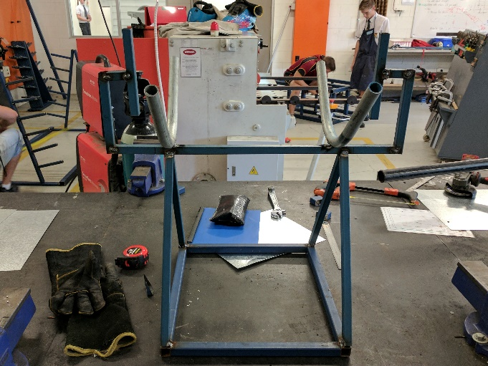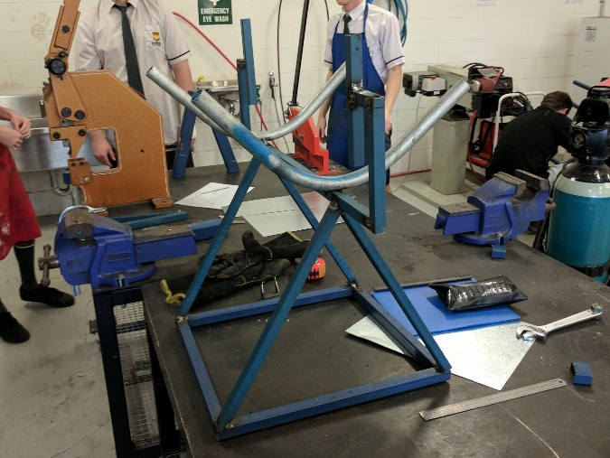

# Prototype #2 survey

I have created a second prototype for my washing machine, so I can get more feedback on flaws, improvements and things that work well. I have made the second prototype a full-size replica so I can get more accurate feedback.

This process of surveying also helped confirm my thoughts that the user will have difficulties operating the machine because the bike will keep pedalling away. It also confirmed my suspicions that the barrel will have difficulties spinning with the barrel full of items.

From this information, modifications will be made to the product to ensure all aspects are considered and all design features are strongly present in the design.

## Experts

|  |  |  |  |  |
| --- | --- | --- | --- | --- |
| Design Criteria | Person 1 | Person 2 | Person 3 | Total (out of 30) |
| Aesthetics | 9 | 7 | 7 | **23** |
| Ergonomics | 9 | 9 | 8 | **26** |
| Anthropometrics | 6 | 7 | 6 | **21** |
| Manufacturing Process | 9 | 8 | 7 | **24** |
| Elements of Design | 9 | 10 | 10 | **29** |
| User-centred Design | 7 | 9 | 5 | **21** |
| Legal Responsibilities | 10 | 10 | 10 | **30** |
| Sustainable Design | 8 | 7 | 6 | **21** |
| Materials | 9 | 9 | 8 | **26** |
|  |  |  |  | 221/240 |

## Non-experts

|  |  |  |  |  |
| --- | --- | --- | --- | --- |
| Design Criteria | Person 1 | Person 2 | Person 3 | Total (out of 30) |
| **Aesthetics** | 9 | 8 | 8 | **25** |
| **Ergonomics** | 9 | 6 | 4 | **19** |
| **Anthropometrics** | 8 | 7 | 8 | **23** |
| **Manufacturing Process** | 8 | 6 | 7 | **21** |
| **Elements of Design** | 9 | 9 | 9 | **27** |
| **User-centred Design** | 9 | 10 | 10 | **29** |
| **Legal Responsibilities** | 9 | 9 | 7 | **25** |
| **Sustainable Design** | 9 | 8 | 8 | **25** |
| **Materials** | 9 | 9 | 9 | **27** |
|  |  |  |  | 221/240 |

## Comments

|  |  |  |
| --- | --- | --- |
| Date | Person: | Comment: |
| 21/04 | Ryan Chessells (peer) | * Useful for developing communities * Welding should be done correctly |
| 21/04 | Kieran Jacobs (peer) | * Doesn’t look good. * Good for developing communities |
| 21/04 | Mr Minchenton (teacher) | * Find a solution for communities that want to use varying size bicycles * The bicycle will have trouble staying in place whilst pedalling * The materials are correct for the design. * Rubber for bike rest? * How easy is the barrel to be moved by the bike? The barrel full of water will weigh 82 kilograms. |

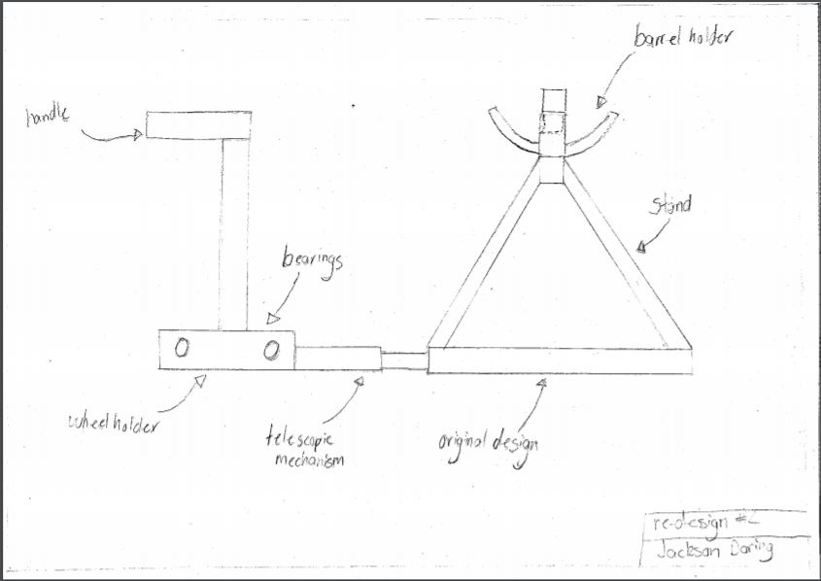

Prototype Modifications #2

### Justification

After the feedback I received from the prototype 2 survey, I have decided to make some modifications to the design to better incorporate the design criteria and make it more user-friendly. Some modifications that have been made are:

* Telescopic mechanism to change the distance between the wheel holder and barrel holder, depending on the size of bicycle wheel in use.
* Eliminating useless materials
* Refining materials to use less steel
* Adding telescopic arms to change the size of the barrel if needed
* Adding a handle for users to lean on while operating machine
* Adding in a wheel holder to stop the bicycle rolling away while operating

# Justification

## RHS

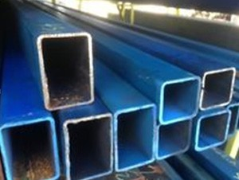

I have chosen RHS as my material for constructing because it’s inexpensive, easily accessible, and easy to work with. It’s also very sustainable because it can easily be recycled and put to other uses, making it convenient and reliable for developing countries.

## Painting



I have chosen painting as the finish for my machine because it’s very inexpensive, easily accessible, and is easy to work with in any environment or on any surface. Adding paint to the machine will make it more desirable and aesthetically pleasing.

## Welding

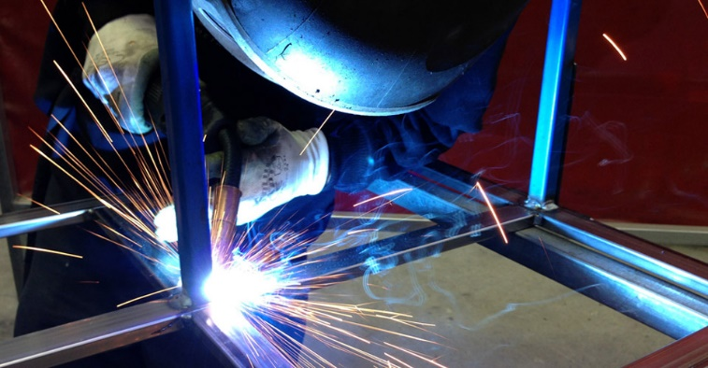

I have chosen welding for my joining method because steel can easily be joined using this method, making the manufacturing process easier and quicker. It’s also easy to work with because it’s a simple and straight forward process.

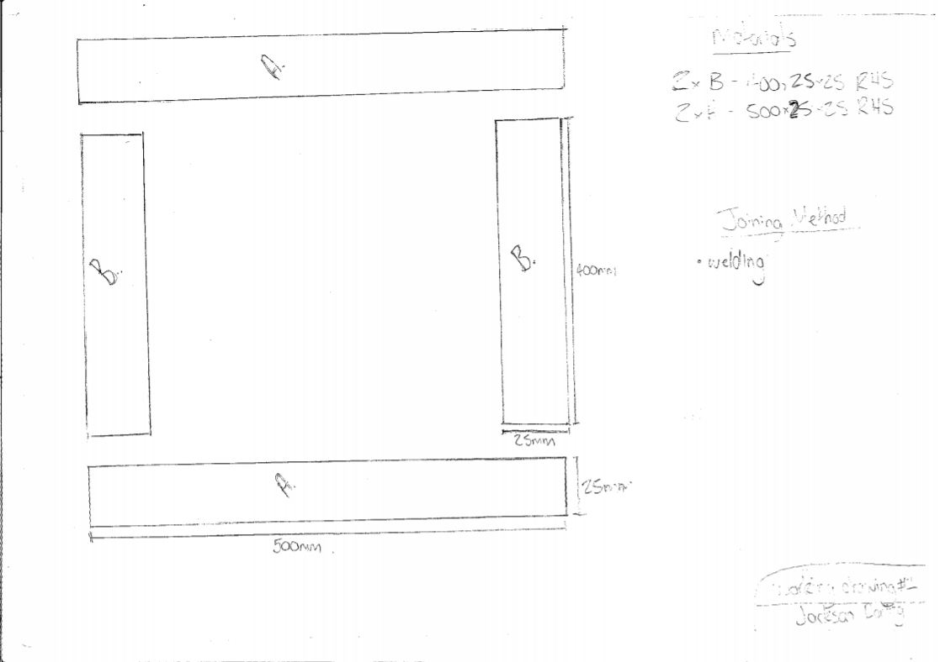

Working Drawings

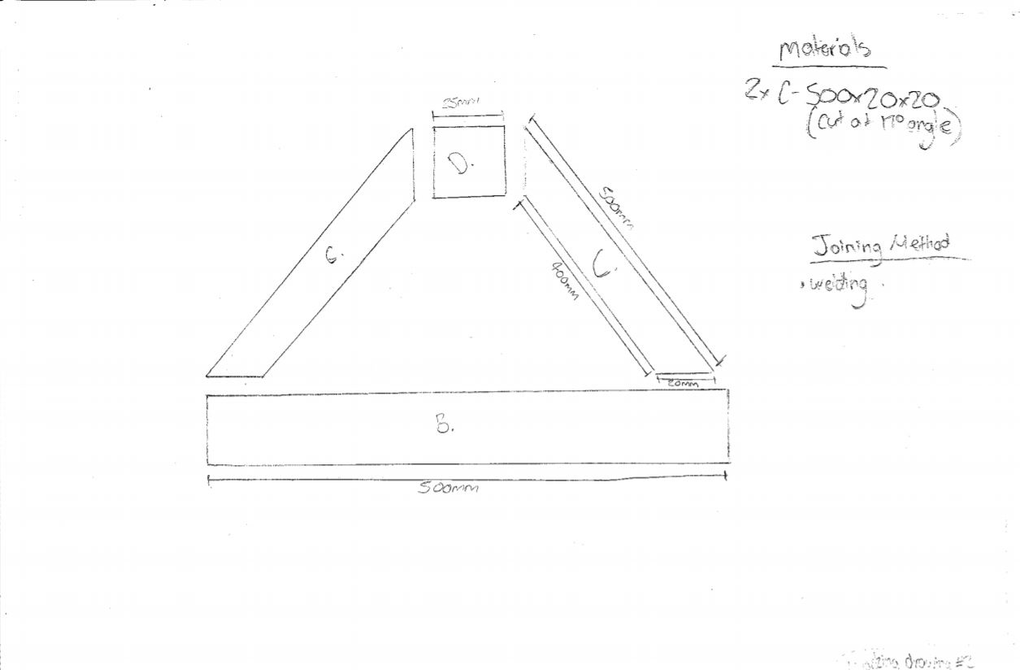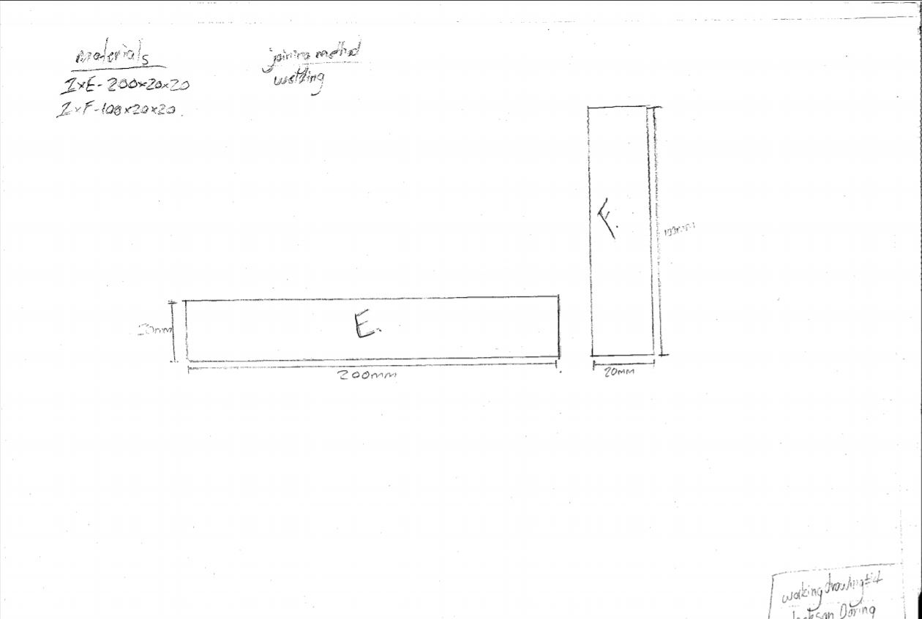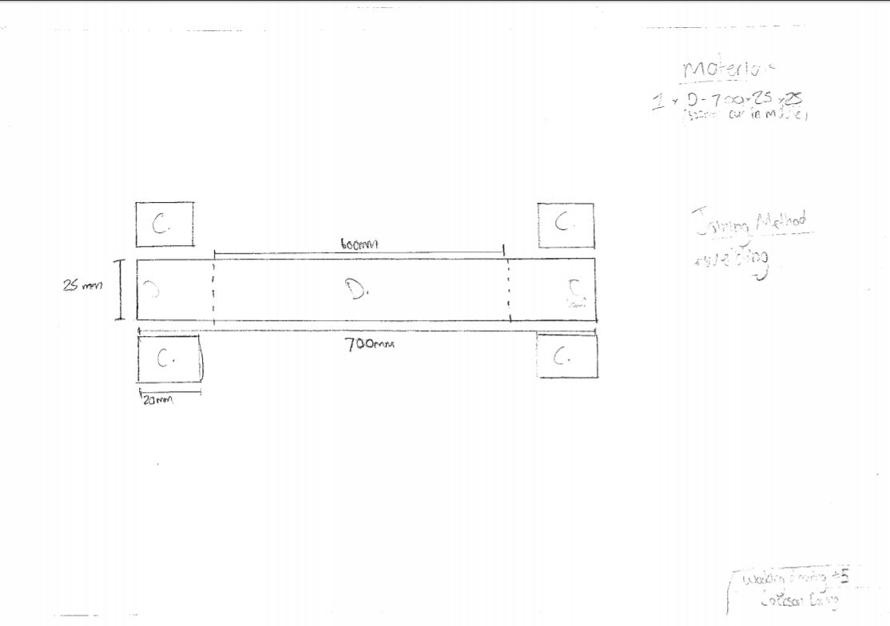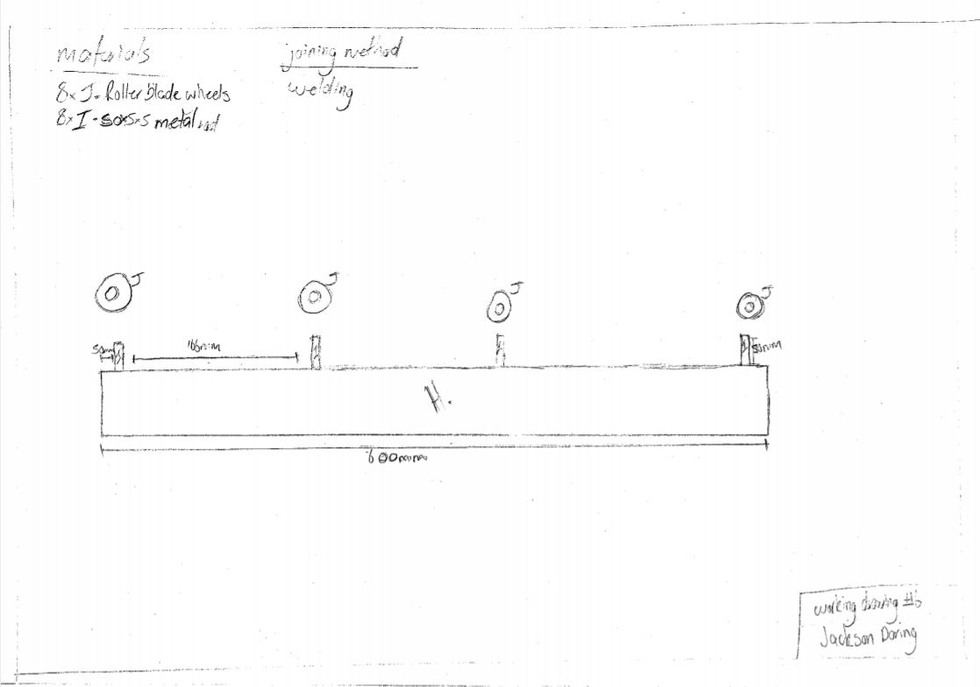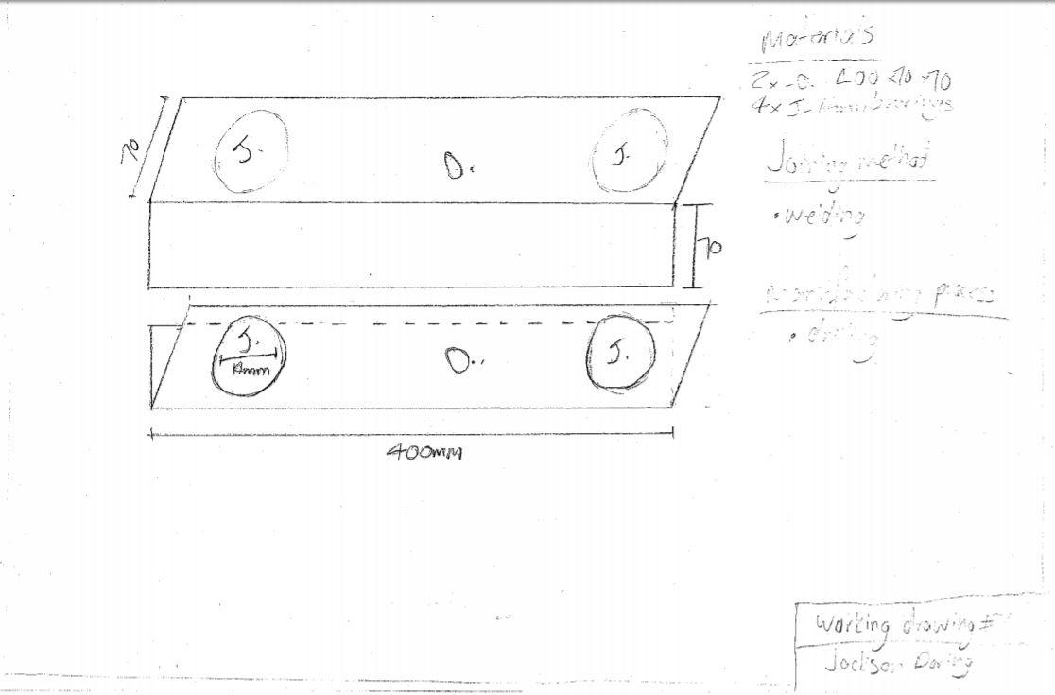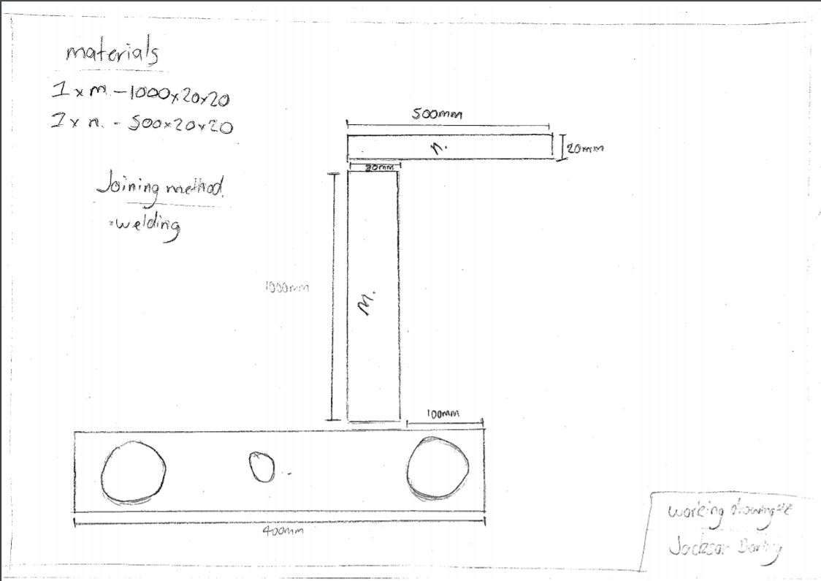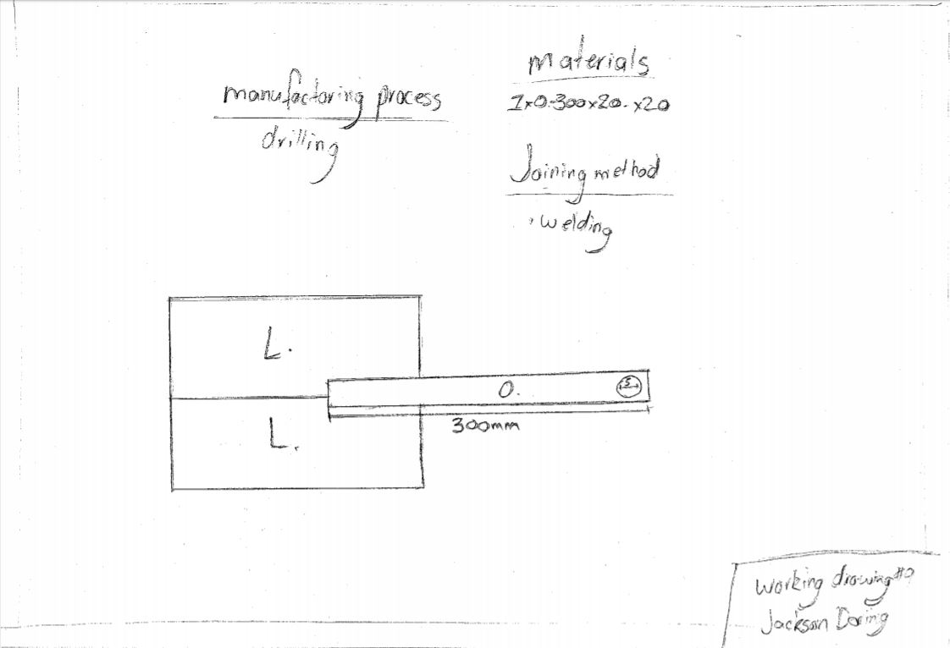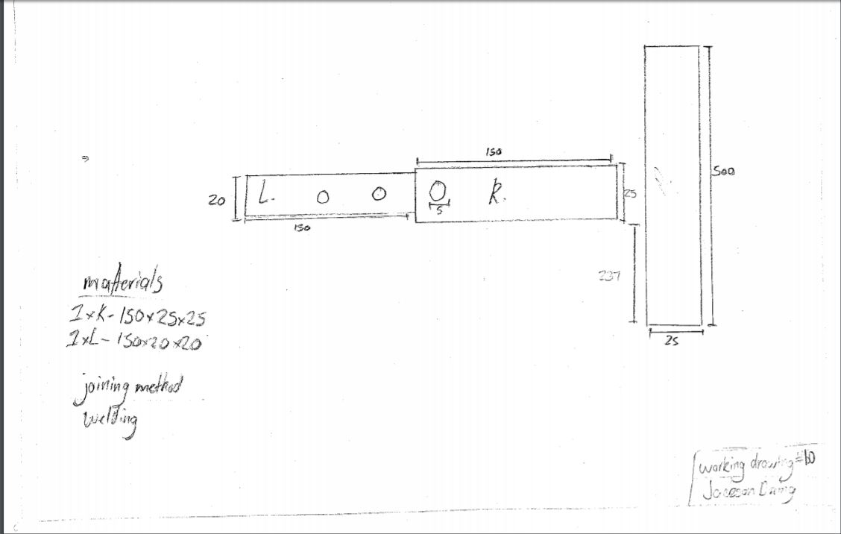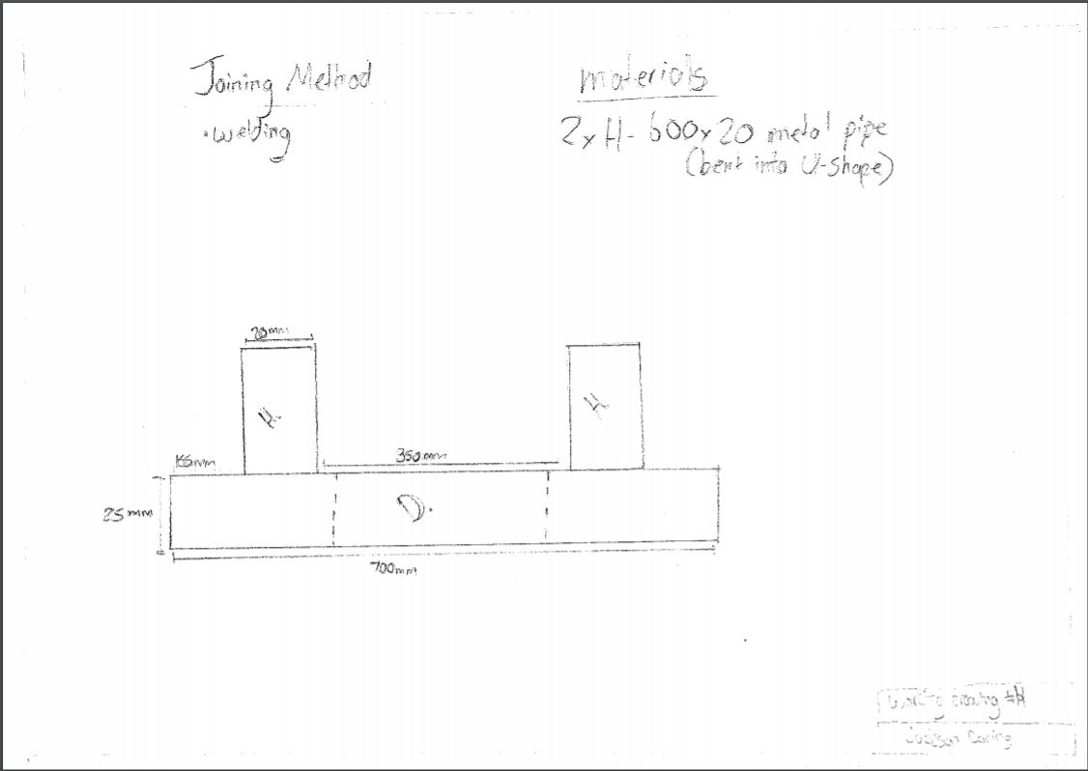

# Material List

|  |  |  |  |  |
| --- | --- | --- | --- | --- |
| Part no. | Description | Size (mm) | No. Required | Material |
| A. | Base; joined with part B | 500 x 25 x 25 | 2 | RHS |
| B. | Base; joined with part A | 400 x 25 x 25 | 2 | RHS |
| C. | Legs; joined with part A and D | 500 x 20 x 20 | 4 | RHS |
| D. | Support for H; joined with part H and C | 700 x 25 x 25 | 1 | RHS |
| E. | Joined with part F | 200 x 20 x 20 | 2 | RHS |
| F. | Joined with part E and G | 50 x 20 x 20 | 2 | RHS |
| H. | Bent into U-shape; joined with part D | 600 x 20 x 20 | 2 | Metal pipe |
| I. | Bearing support | 10 x 5 x 5 | 8 | Metal pipe |
| J. | Roller blade wheels | 80 | 8 | ------------ |
| K. | Telescopic connection | 150 x 25 x 25 | 1 | RHS |
| L. | Telescopic connection | 150 x 20 x 20 | 1 | RHS |
| M. | Handle; joined to N and O | 1000 x 20 x 20 | 1 | RHS |
| N. | Handle; joined to M | 500 x 20 x 20 | 1 | RHS |
| 0. | Holds bearings | 400 x 70 x 70 | 2 | Steel |
| P. | Bearings | 14 | 4 | --------------- |

# Work Method Statement

|  |  |  |  |  |
| --- | --- | --- | --- | --- |
| Key Stage of Production | Hazards | Level of Risk | Hazard Control | Responsibility |
| Cutting Metal | Cuts from blade | Low | Operating machinery with all necessary safety equipment | Myself |
| Welding | Burns, blindness | Medium | Using all provided safety equipment and being responsible with equipment | Myself |
| Bending Metal Pipes | Crushing body parts | Low | Making sure to keep all body parts away from machine while in use | Myself |
| Grinding | Cutting self and sparks in eyes | Low | Wearing all necessary safety equipment and using machinery correctly | Myself |
| Drilling | Cutting self | Low | Wearing all necessary safety equipment and using machinery correctly | Myself |
| Lathing | Cuts | Low | Wearing all necessary safety equipment and using the machine correctly. | Myself |

# Construction Process

## Drilling

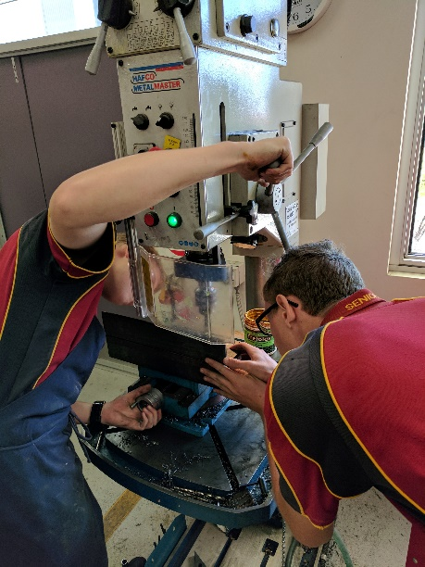

## Grinding

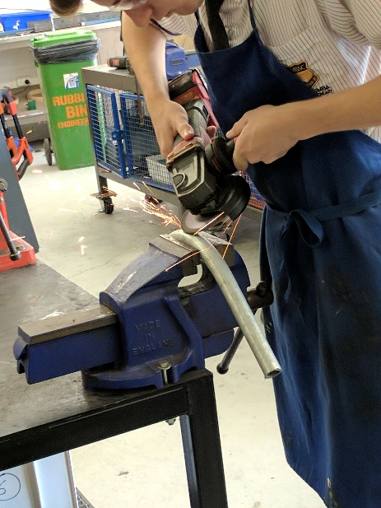

## Cutting

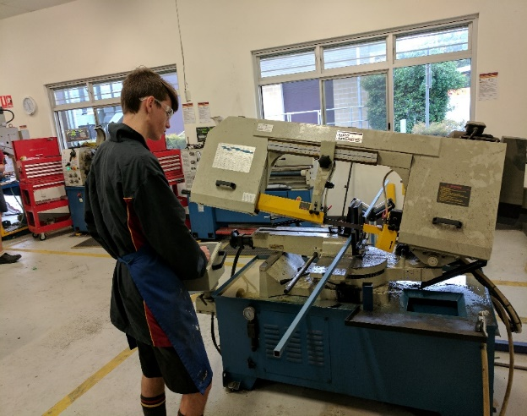

## Welding

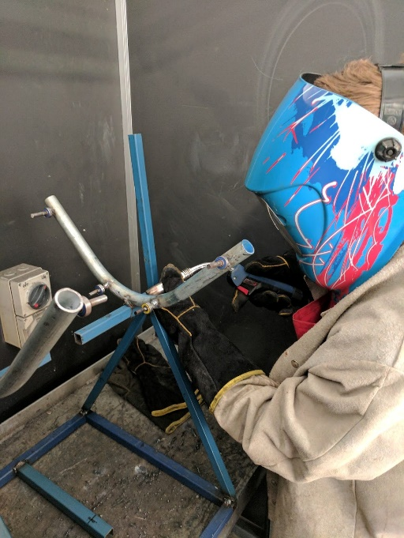

## Visualisation

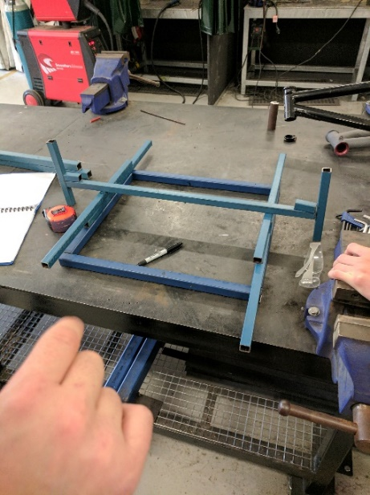

## Assembly

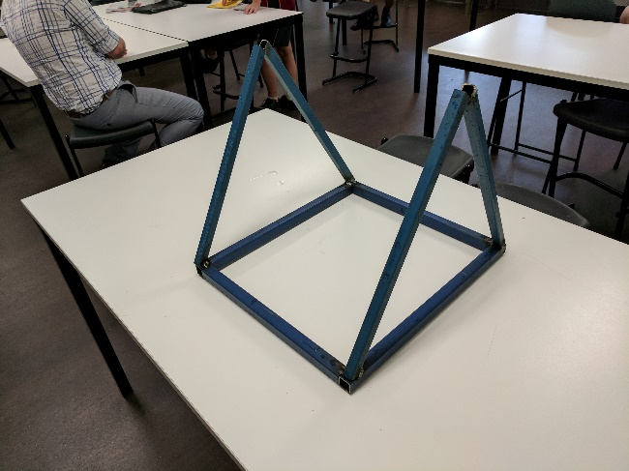

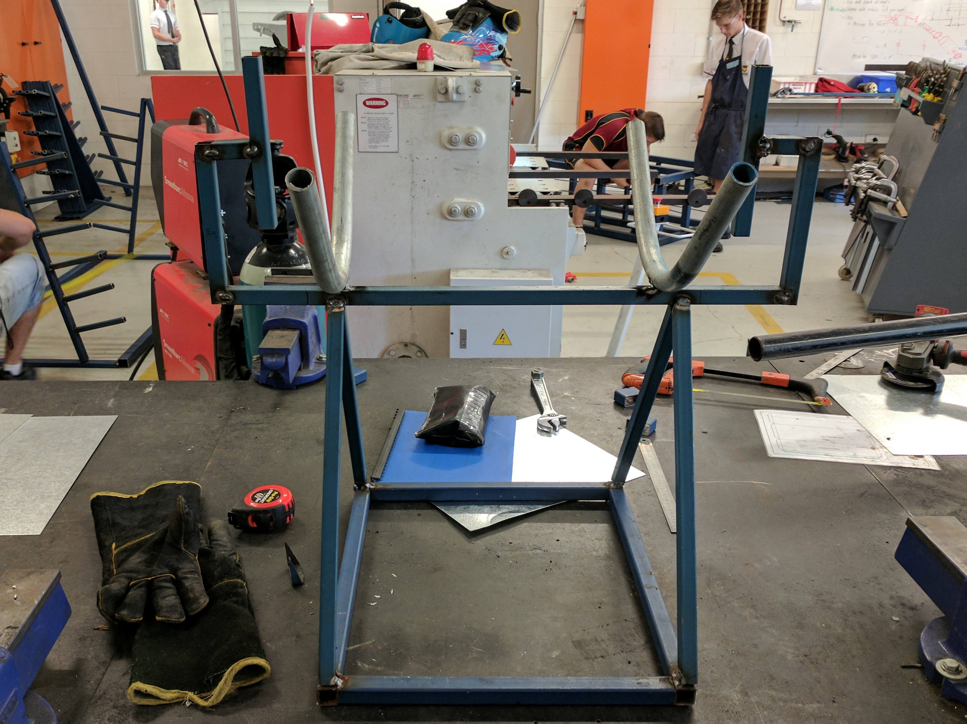

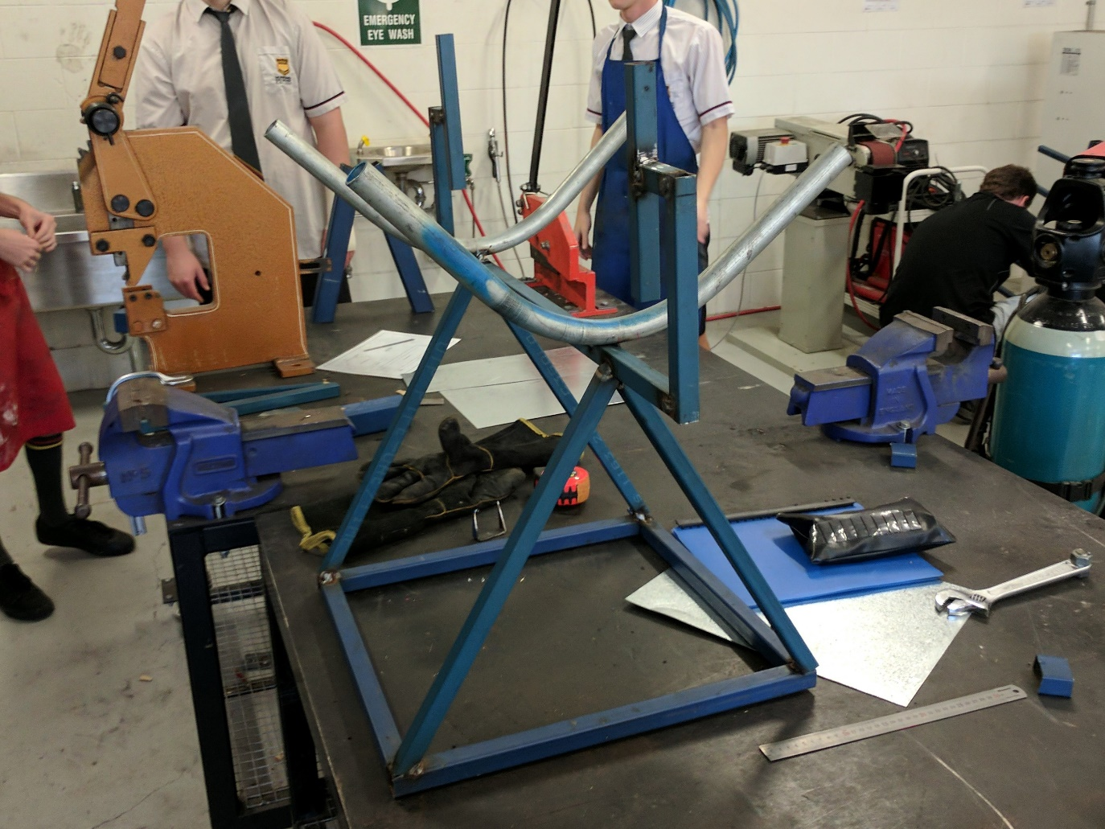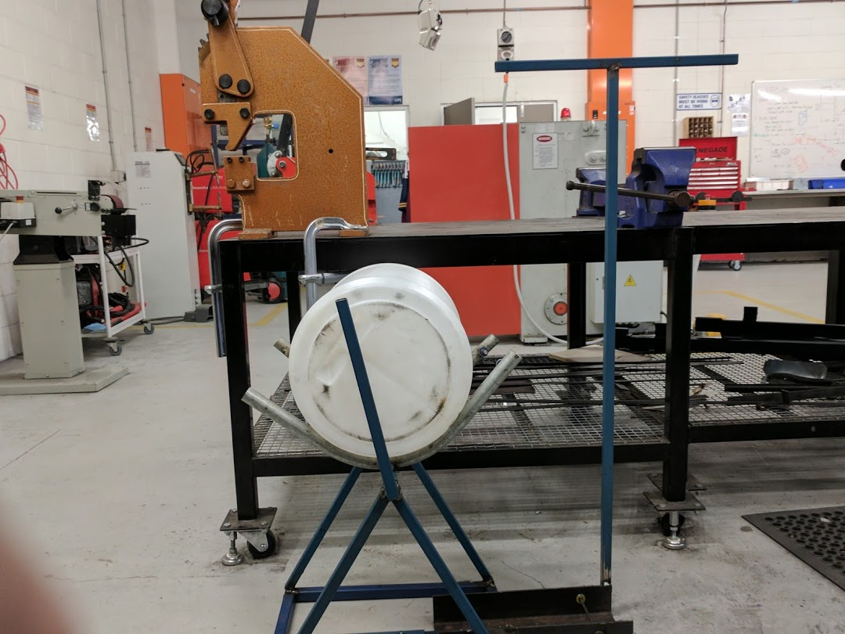

Final Product

Back

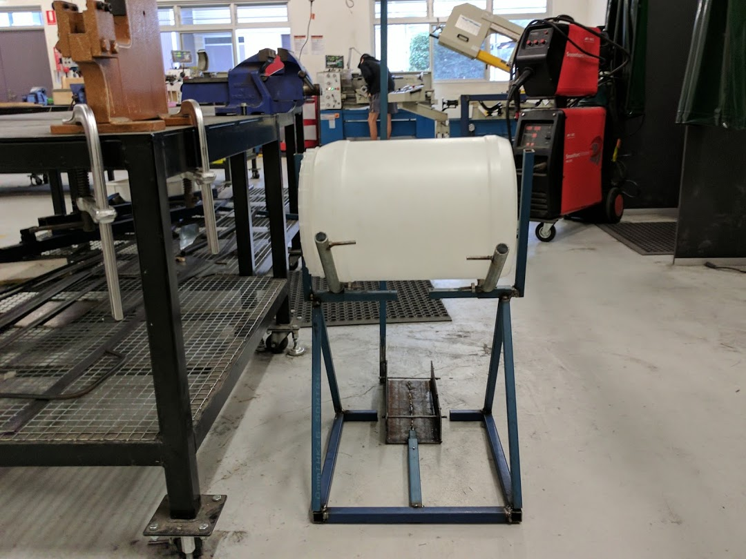

Side



3D view

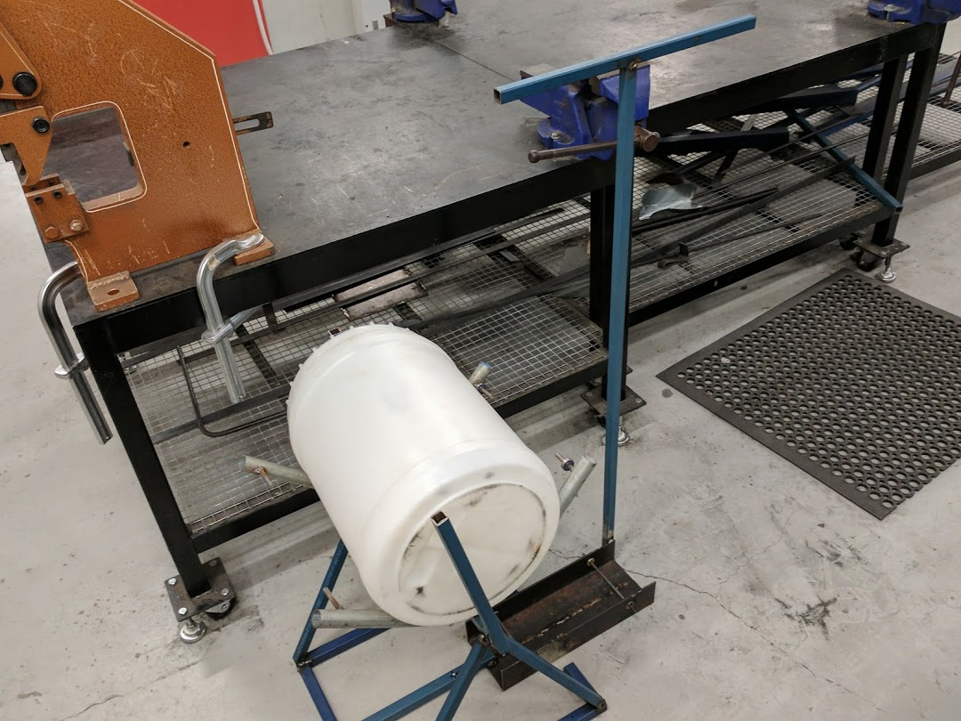

Top

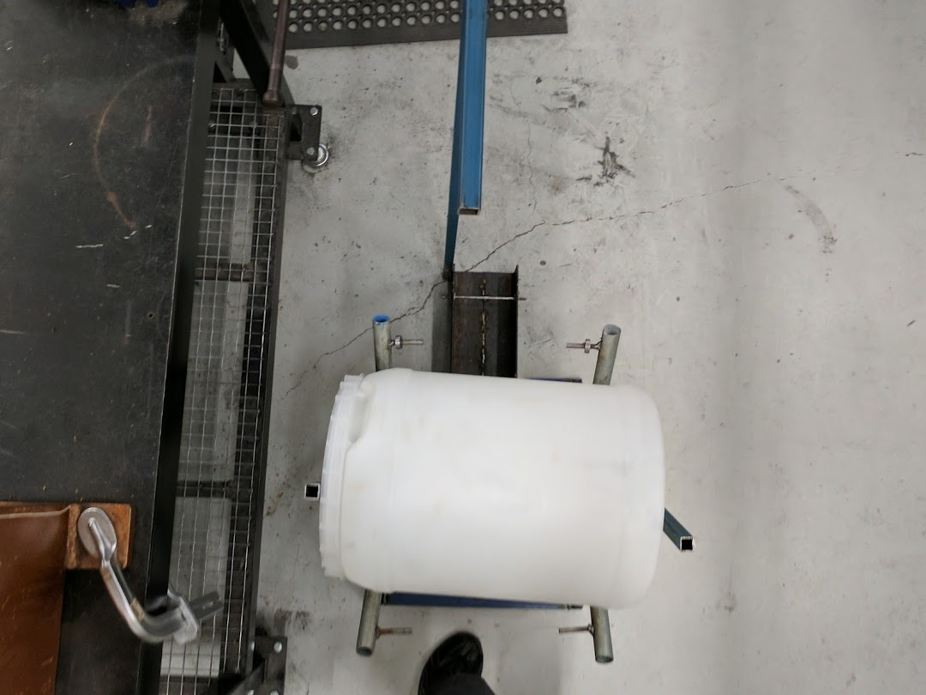

# Final Product In Use

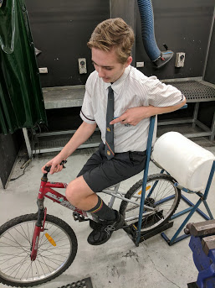

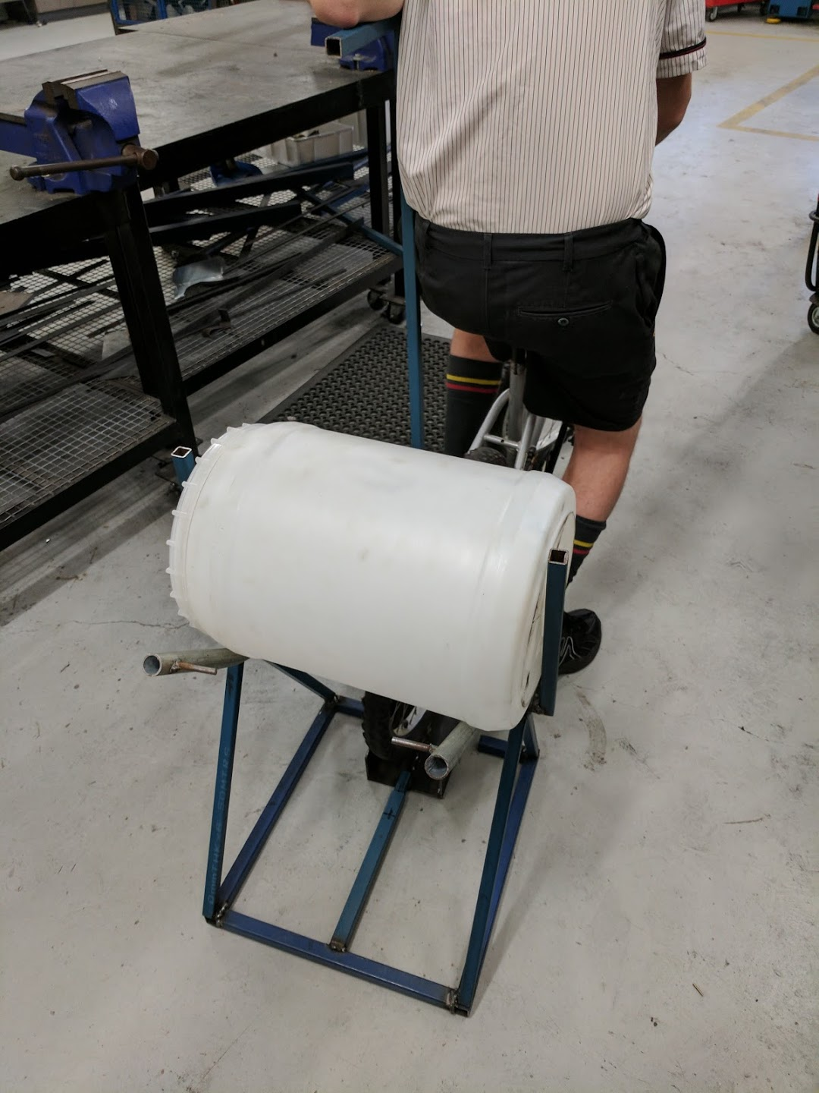

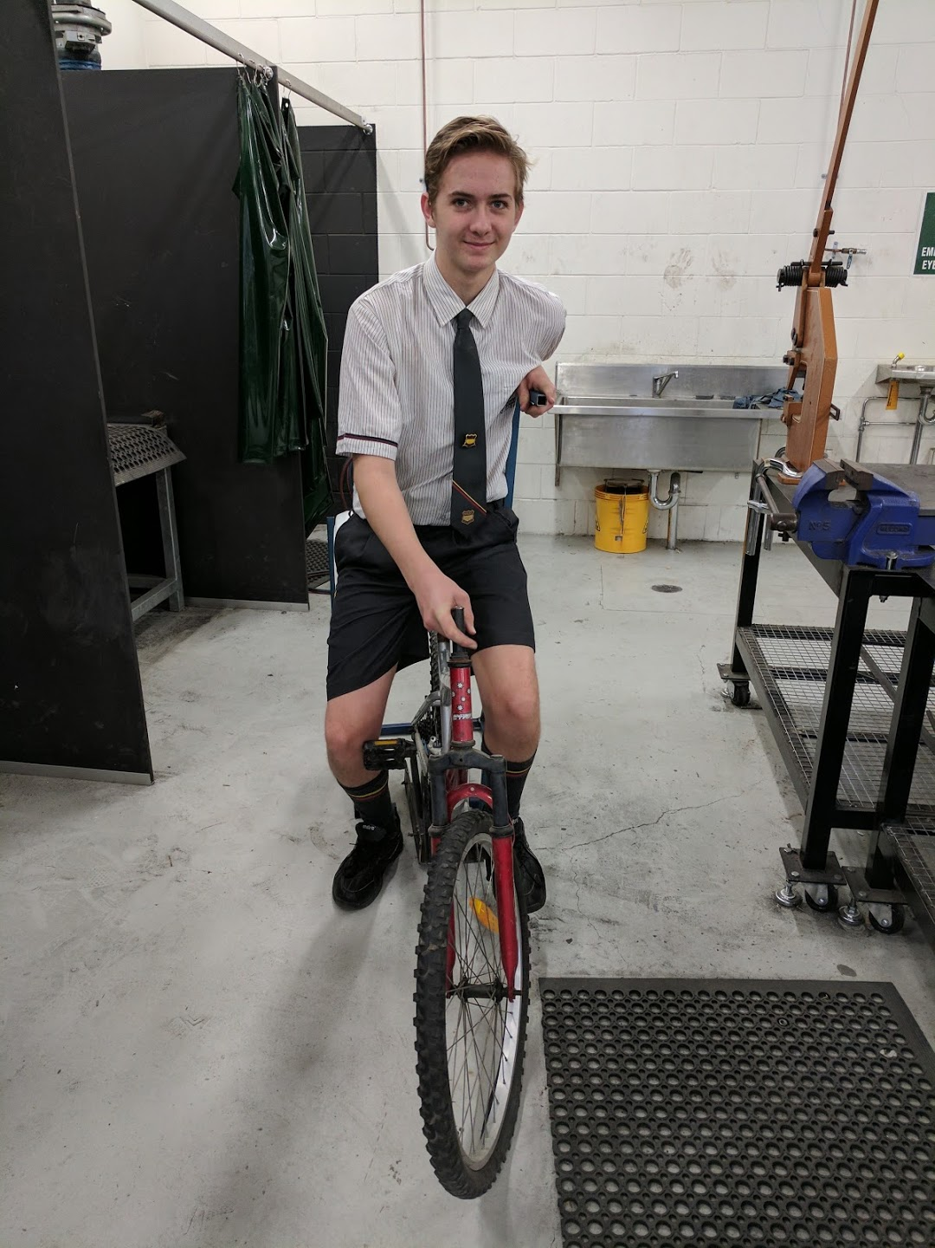

# Appraisal

## What went well

I believe the project went well, I was able to effectively follow my timeline, resulting in me finishing on time. My final product has been successful by being designed and built according to the design criteria and design brief. It has successfully reached the design brief by allowing developing countries to easily and effectively wash and sanitize their clothes using prior knowledge and resources. It has reached each design criteria because:

***Elements of Design:*** It’s able to comfortable fit over 20 clothing items because of its 22-gallon drum. The bicycle is incorporated by having it run the washing machine.

***User Centred Design:*** The machine can be easily operated by less experienced communities in developing countries because it’s operated by doing something as simple as riding a bicycle. The machine is light enough to transport between communities, this is because the machine can be taken apart in two pieces, making it easily to carry; the machine was also designed with only the absolute necessary materials needed, making it lighter.

***Materials:*** Using RHS for the material is very cost effective and sustainable. The machine is easily transportable because RHS is a light material.

***Legal Responsibilities:*** The design is an original concept, which means there will be no problems with copy right infringements. There are no elements visible that can easily cause injury to the users, which means there will be no problems with getting sued for injuries. The machine is light, which means the users aren’t likely to suffer muscle or ligament injuries while transporting the machine.

***Manufacturing Process:*** The machine could be manufactured using only the equipment provided by the school.

***Sustainable Design:*** The machine has been designed to make sure minimal maintenance needs to be done during the life of the product, this has been done by using no moving parts or mechanics. The machine is built to last because of its primarily steel based design. The machine is a sturdy build because of it’s made from steel and is welded together.

***Ergonomics:*** The machine is comfortable and desirable to use by majority of users because all they’ve got to do is sit on a bicycle and pedal also, having an armrest means the operation of the machine is more comfortable. All the user interactions are comfortable because all they’ve got to do is ride a bicycle.

***Anthropometrics:*** The pedals are an average adults leg length away from the bicycle seat, the arm rest is at the average height of an adults’ arm distance from the ground while sitting a bicycle.

***Aesthetics:*** The aesthetics of the machine isn’t very good, however it doesn’t matter for this design criteria.

## Prototypes & Surveys

By creating prototypes and doing surveys from them, I was able to refine my designs to make them better and to reach the design criteria better. As you can see from the graph, after each survey was conducted, there was an increase in most of the design criteria’s from both groups of people. This is because after each survey I took the results and comments from them and made modifications accordingly. If more prototypes and surveys were to be completed, then the product would keep improving and refining.

## Top 6 design criteria justification

* I have given an A to the first *User-centred design* criteria because I feel I have effectively implemented design features to better suit the machine for developing countries. I have done this by making the operation of the machine as simple as riding a bicycle, I have also used a barrel with a tap so water can be filtered and reused, and I have also implemented a full bicycle so it can also be used for transportation.
* I have given a B to the second *User-centred design* criteria because I feel I have effectively used materials to make the machine easily transportable however, with more design details, this criteria could have been better. I have made the machine easily transportable by using steel as the primary material because it’s light, and also only using materials that are necessary.
* I have given a B to the *Material* criteria because I have chosen a reasonable material that’s cheap, sustainable and eco-friendly however, a better material could have been selected if it was available at the school.
* I have given an A to the first *Sustainable Design* criteria because I have effectively used materials to minimise maintenance during the life of the machine, I have done this by not implementing any moving parts or adding in any complex mechanics that would need frequent repairs.
* I have given an A to the second *Sustainable Design* criteria because I have effectively used materials to make the machine more resistant to harsh conditions. I have done this by creating a sturdy frame and using steel as the primary material.

I have given an A to the *Anthropometrics* criteria because I feel I have effectively researched and implemented anthropometrics into the machine. I have done this by researching the average heights of adult body parts, then implementing them accordingly into each component.

## What went wrong

If I was to complete the project again, I would create a more effective timeline that is tailored to my abilities because I found myself spending more time building the machine then I allocated for it. This happened because I was inexperienced with all the construction processes used and had to get tutorials from fellow peers

Top 6 design criteria sheet

|  |  |  |  |
| --- | --- | --- | --- |
|  | A standard | B standard | C standard |
| User centred design | * Comprehensive analysis and effective implementation of design features to better suit the machine for developing communities * Thorough design plans and effective use of materials to create an easily transportable machine | * Analysis and effective implementation of design features to better suit the machine for developing communities * Detailed design plans and use of materials to create an easily transportable machine | * Effective implementation of design features to better suit the machine for developing communities * Descriptive design plans and use of materials to create an easily transportable machine |
| Materials | * Comprehensive and discerning analysis of material choices for a cost effective, eco-friendly and sustainable machine | * Detailed analysis of material choices for a cost effective, eco-friendly and sustainable machine | * Analysis of material choices for a cost effective, eco-friendly and sustainable machine |
| Sustainable design | * Discerning research and use of materials to minimise maintenance during the life of the machine * Sufficient and effective use of suitable materials and design plans to help the machine withstand harsh conditions and last for years | * Proficient research and use of materials to minimise maintenance during the life of the machine * Effective use of suitable materials and design plans to help the machine withstand harsh conditions and last for years | * Research and use of materials to minimise maintenance during the life of the machine * Use of suitable materials and design plans to help the machine withstand harsh conditions and last for years |
| Anthropometrics | * Thorough analysis and implementation of anthropometrics for a better user centred design | * Detailed analysis and implementation of anthropometrics for a better user centred design | * Analysis and implementation of anthropometrics for a better user centred design |

# References

"Anthropometry Data Table". N.p., 2017. Web. 10 Apr. 2017.

"Camping Washing Machine - Google Search". *Google.com.au*. N.p., 2017. Web. 12 April 2017.

"The Sustainable Material | Tata Steel In Europe". *Tatasteeleurope.com*. N.p., 2017. Web. 10 June 2017.

"Washing Machine - Google Search". *Google.com.au*. N.p., 2017. Web. 13 May 2017.

"Water And Sanitation - United Nations Sustainable Development". *United Nations Sustainable Development*. N.p., 2017. Web. 14 April 2017.